1. In order to demonstrate your understanding of Programming within an Object Oriented visual environment you are required to develop and test software based on your design, to replace the current manual process for collecting, analysing and storing ‘Step Test Data’.
2. You are also required to evaluate your solution in relation to your design, usability and functionality. The evaluation will include a description on your chosen testing strategy with appropriate plans, logs and results, identifying differences between expected and actual results. If your solution differs from your original design, document the differences and describe why. The evaluation provides an opportunity to achieve additional marks by describing design features, functionality, good practice and enhancements.

**Guidance:**

Your tutor will act as the customer and as such, will be available for interview during class / lab sessions. However, the document used for recording the current manual process is given below which includes the following instructions for the graphical analysis:

1. Plot the heart rate at each of the levels until they achieve approximately 85% of their max HR. Nb. ensure the levels correspond to the correct step height.
2. Draw a straight line that best fits these points.
3. Extend this line to cross their max HR line for their age.
4. Drop a line from this intersection to the baseline and read the predicted aerobic capacity (units mls02/kg/min)

Additional customer notes and observations (often vague and undefined):

* The test may be performed by a single individual but equally, the test could be applied to a group of participants. The participants details can be entered manually before each test or the list of participant details can be imported prior to the test session taking place. In this case, the operator will select a participant before each test.
* The step height can differ but it is specified and fixed for any particular testing session.
* Once the parameters have been defined and set for each test the participant will commence the first step test. On completion, the first heart rate reading will be taken and recorded.
* Any recorded HR less than 50% of the maximum HR will be ignored in the final calculation. • The participant will then continue this process up to a maximum of FIVE tests or until the HR reading is above 85% of the maxHR.
* Any recorded HR greater than 85% of the maximum HR will conclude the test but will be ignored in the final calculation.
* Once the reading exceeds 85% the testing is over for the current participant.
* Currently the paper documents are filed for reference so the data and results for each test will need to be stored in a persistent database. Users should be able to switch to a different screen to query previous test data of the current participant.
* Once an individual participant has completed the test the system will need to reset ready for the next participant.
* The system will need to deal with special cases, i.e. If there’s no - or only one - valid reading

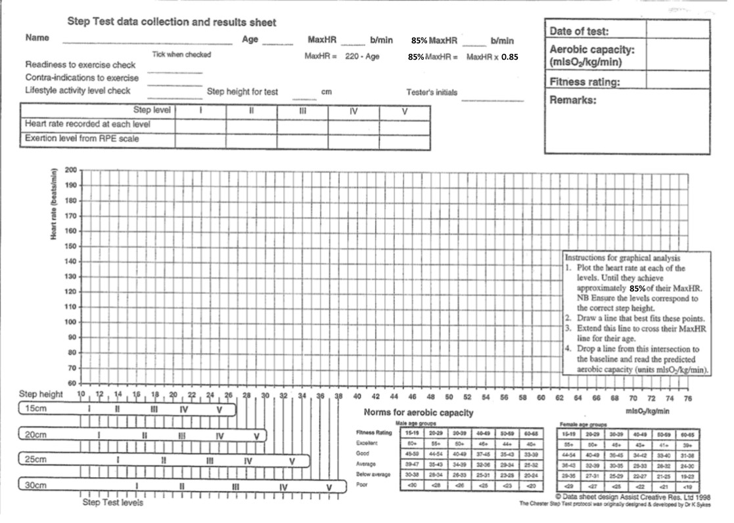

**Further guidance:**

You should work individually on this assignment

The design of a realistic and easy-to-understand user interface is expected.

Your solution should include classes, methods and event/general functions as appropriate. Refer to the Assessment criteria below for guidance on how to pass this assignment. Your work will be assessed on how you define / model the requirements in your design documentation and how you communicate your design decisions. You may obtain further guidance from the module tutor.

**Submission:**

* All solution files and associated documentation will be submitted through Moodle
* You will be required to demonstrate your solution where you will have the opportunity to discuss your code and design decisions.

**Late submission of work**: Work submitted up to a week late without a valid reason can only gain a maximum of 40%. Any work submitted more than a week late without a valid reason may be read but will not be marked.